JDY-31 Bluetooth Module + Circuit Explanation
A Bluetooth module refers to the basic chip circuit set integrating Bluetooth functionality for wireless communication. This Bluetooth module is specially designed for wireless data transmission. It supports a serial interface and the SPP Bluetooth serial protocol, and it features low cost, small size, and high transceiver sensitivity. Only a few external components are required to achieve useful functions.
- Product Features
The JDY-31 Bluetooth module is designed based on Bluetooth 3.0 SPP, enabling transparent data transmission with Windows, Linux, and Android. It operates in the 2.4 GHz frequency band, uses GFSK modulation, has a maximum transmit power of 8 dB and a maximum transmission distance of 30 m, and supports AT commands for modifying the device name, baud rate, and other parameters. It is convenient, flexible, and can only be used as a Bluetooth slave device.
II. Scope of Application
The JDY-31 can communicate with Bluetooth-enabled computers and Android phones. It can be used for Android Bluetooth serial transparent transmission, smart home control, automotive OBD diagnostic devices, Bluetooth toys, shared power banks, and shared smart scales and medical devices.
III. Product Parameters
1. Operating frequency: 2.4 GHz
2. Communication interface: UART
3. Operating voltage: 1.8-3.6V, 3.3V recommended
4. Operating temperature: -40°C to 80°C
5. Antenna: built-in PCB antenna
6. Transmission distance: 30 m; supported role: slave
7. Bluetooth version: Bluetooth 3.0 SPP
8. SMT soldering temperature: < 260°C
9. Unconnected operating current: 4.7 mA
10. Current after BLE connection: 7.3 mA
11. Transmit power: 8 dB max
12. Receive sensitivity: -97 dBm SPP
13. Maximum throughput: 16 Kbytes/s (Android, Windows)
14. Module size: 19.6 x 14.91 x 1.8 mm
IV. Module Interface Description:
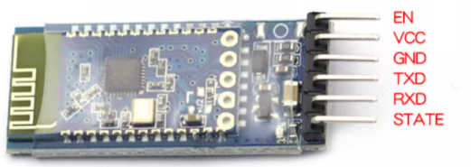

(1) EN: not connected
(2) VCC power supply (supports 3.6-6V)
(3) GND: connect to GND
(4) TXD: serial output, TTL level
(5) RXD: serial input, TTL level
(6) STATE: connection status pin (low level when not connected)
In general use, the EN and STATE pins are left unconnected, and only the middle four pins are used.
The interface circuit diagram of the Bluetooth module is shown below.
Bluetooth module circuit schematic
The physical picture of the Bluetooth module is shown below.
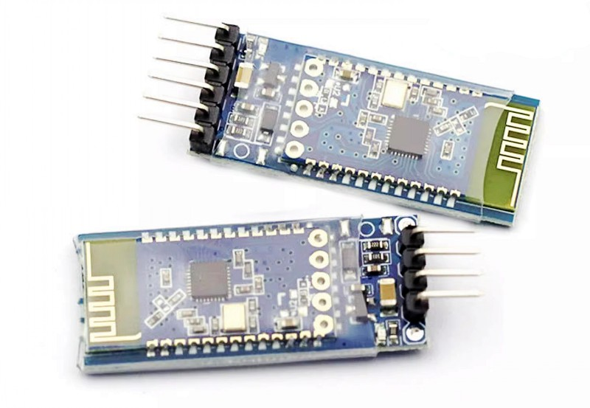
Physical picture of the Bluetooth module

